Weather Data Protocol
Supplementary document to be used in conjunction with Graduate Thesis at:
https://ir.library.oregonstate.edu/concern/graduate_thesis_or_dissertations/bv73c8453?locale=en

Note: This protocol describes in more detail the general procedure used in the graduate thesis for processing the weather data for the SWAT model. For thesis project specifics please defer to the graduate thesis (see Section 2.5.4 Model Creation: Edit Inputs), since any figures and numbers included here may be outdated. For future projects, changes can be made depending on specific needs, but are outside the scope of this protocol.

References: This protocol is largely derived from scripts initially provided by Justine Obiazi.
Images in this script were produced using the following sources:
- Microsoft. (n.d.-a). Microsoft Excel [Computer software].
- Microsoft. (n.d.-b). Microsoft PowerPoint [Computer software].
- Microsoft. (n.d.-c). Windows Notepad [Computer software].
- PRISM Group. (2024). PRISM weather data [Dataset]. Oregon State University. https://prism.oregonstate.edu/explorer/map.php
- QGIS Association. (n.d.). QGIS (Version 3.32.3) [Computer software]. http://www.qgis.org/
- Texas A&M AgriLife Research (TA&MAR), & United States Dept. of Agriculture Agricultural Research Service (USDA ARS). (2012). Soil and Water Assessment Tool [Computer software]. https://swat.tamu.edu/

- Obtained 4km Polygon mesh from: https://prism.oregonstate.edu/downloads/
- Got grid intersection point lat/long coordinates for all 4km cells that encapsulated QSWAT Model. If very close to borders, a buffer cell was added.
- Then created .csv file with latitude column, longitude column, and name. For naming—starting at top left intersection— first intersection was called Location 1 (top left), then Location 2 (top right), then Location 3 (2nd row top left), then Location 4 (2nd row top right) and so on. (See drawn numbers on example image)
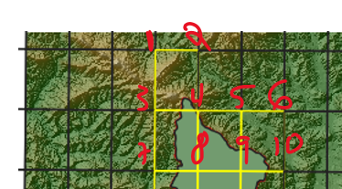

- Next went to PRISM Data Explorer: https://prism.oregonstate.edu/explorer/
- Next clicked on Download data from multiple locations: https://prism.oregonstate.edu/explorer/bulk.php
- Precipitation, Minimum Temp, and Maximum Temp were selected. Daily values were selected but can only be downloaded one year at a time. SI system was selected (will be in mm and C degrees). Interpolate grid cell values was turned on
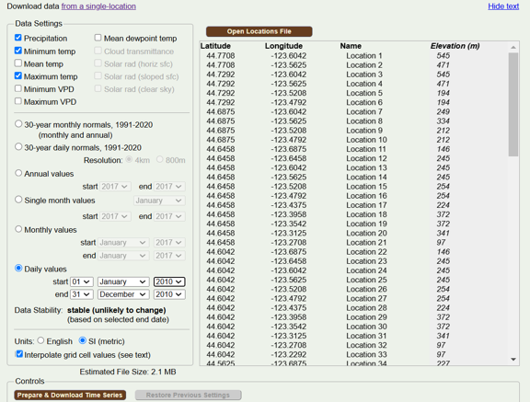
- Relevant years were downloaded (for this example just 2010 and 2011) as CSVs and placed in a folder named Raw Data. Scripts will convert this raw CSV data into the processed weather data.
- prism_data_separation was run using the downloaded 2010 PRISM CSV as an input (see Inputs section of script for other needed inputs)
  - This script separated out precipitation, minimum temperature, and maximum temperature data to create individual CSVs of each (for 2010). Image below is snippet of output for precipitation
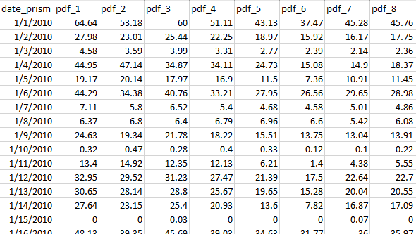
  - Note: The code section is automated and only the Inputs section requires user changes. Run this script for each relevant year of data by updating the Inputs section each time (e.g. prism_data_separation was rerun but this time with the downloaded 2011 PRISM CSV along with the other Input changes)
  - Note: When creating the output filepaths, know that for the next script, resultant CSVs need to be organized as follows:
    - Intermediate Outputs folder
      - Precipitation folder
        - Precipitation CSVs
      - Temperature folder
        - Minimum Temperature subfolder
          - Minimum Temperature CSVs
        - Maximum Temperature subfolder
          - Maximum Temperature CSVs

- prism_concatenate_data was run to take the separated data folders (Precipitation, Minimum Temperature, Maximum Temperature) and concatenate all the files within each folder to create three CSV outputs, respectively
  - Note: When creating the output filepaths, know that for the next script, resultant CSVs need to be organized as follows:
    - Intermediate Outputs folder
      - MergedCSVs folder
        - The output CSVs
- The merged Precipitation data now needs to be preprocessed by the following scripts:
  - csv_to_text
    - This takes the previously combined precipitation CSV and creates individual text files for the precipitation data at each Location point. This means each text file corresponds to a single Location and is composed of a single column of data (no headers) where each row is the precipitation data for the day in question at the Location
    - Names will currently range from gage_1.txt to gage_[Last Location Number].txt
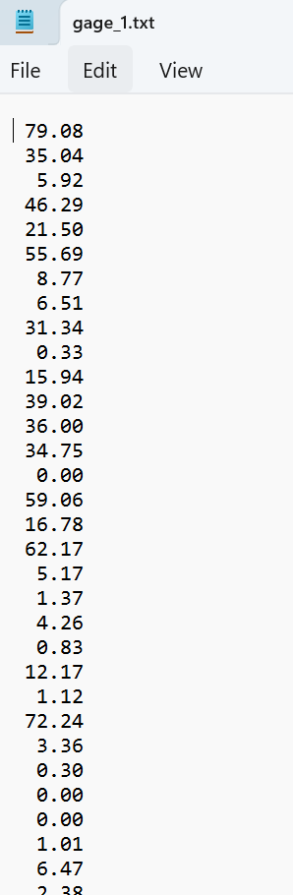
    - Note: When creating the output filepath, know that for the next script, resultant text files need to be organized as follows:
      - Intermediate Outputs folder
        - TextFiles folder
          - Precipitation_TextFiles folder
            - The output text files
  - add_first _row
    - This takes a folder as an input (the Precipitation_TextFiles folder that contains the text files) and will add the user-specified start date yyyymmdd (e.g. 20100101) as the first row to each text file in the folder. This is done because SWAT requires that the first row of the input files be the start date
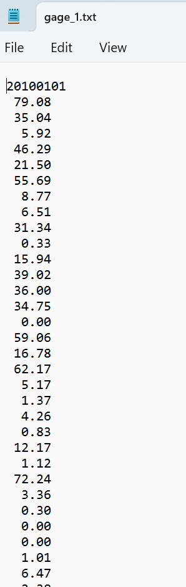
  - update_textfile_name
    - This takes a folder as an input (the Precipitation_TextFiles folder that contains the precipitation text files) and will find the text files that begin with “gage_” and rename so that only the number is left (e.g. gage_1.txt will be renamed to 1.txt)
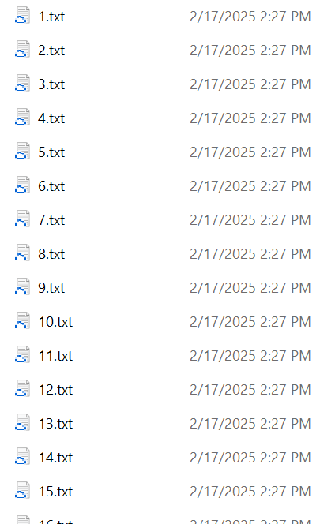
- The merged Minimum and Maximum Temperature data now needs to be preprocessed by the following scripts:
  - combine_two_csv
    - This takes the previously created merged Minimum Temperature and merged Maximum Temperature CSVs and combines them to create individual text files for each gage Location point, where each row represents a single day and is in the format: Max_Temp Min_Temp
    - Note: The following issues will be corrected by later scripts:
      - A header is included in each text file (as a value of 0)
      - No commas exist between the temp values
    - Names will currently range from gage_1.txt to gage_[Last Location Number].txt
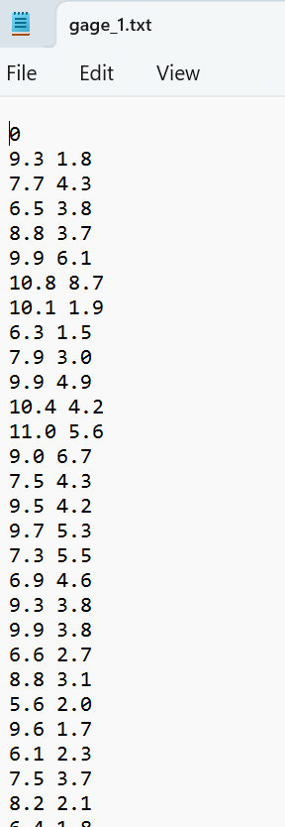
    - Note: When creating the output filepath, know that for the next script, resultant text files need to be organized as follows:
      - Intermediate Outputs folder
        - TextFiles folder
          - Temperature_TextFiles folder
            - The output text files
  - update_textfile_name
    - Important: This is the same file that is used for the precipitation text files and so make sure to update all the necessary inputs
    - Refresher: This takes a folder as an input (the Temperature_TextFiles folder that contains the temperature text files) and will find the text files that begin with “gage_” and rename so that only the number is left (e.g. gage_1.txt will be renamed to 1.txt)

  - replace_first_row
    - This takes a folder as an input (the Temperature_TextFiles folder that contains the temperature text files) and will replace the “0” in the first row of each text file within the folder with the user-specified start date yyyymmdd (e.g. 20100101). This is done because SWAT requires that the first row of the input files be the start date
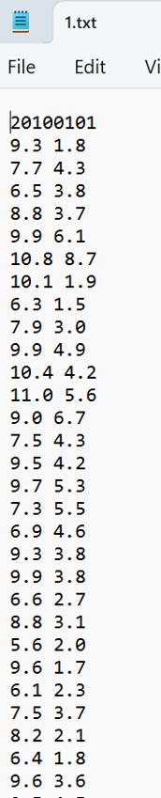

  - add_commas
    - This takes a folder as an input (the Temperature_TextFiles folder that contains the temperature text files) and within each text file within the folder, will replace the separating space with a comma for each row that contains two numeric values
      - This means the first row (with the date) will be excluded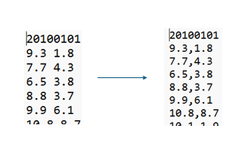
- In addition to the processed precipitation and temperature text files within their individual folders (Precipitation_TextFiles, Temperature_TextFiles), SWAT requires an additional text file that ties the numbered text files to physical locations
- Started in Excel and created 5 columns with the following headers:
  - ID – Consecutive, unique ID from 1 to total number of locations
  - NAME – This is what ties to the numbered text files. Because of the naming convention used for the Precipitation and Temperature text files (numbers), NAME will equal ID for each row
  - LAT – Latitude coordinate
  - LONG – Longitude coordinate
  - ELEVATION – Elevation in meters
    - LAT and LONG information can be obtained from the csv file used to obtain data from PRISM (see Page 2 of this protocol)
    - ELEVATION information can be obtained on PRISM site once the input csv is opened (see Page 2 of this protocol)

- Filled out the Excel table for each of the locations
  - So for 100 locations there were a total of 5 columns and 101 rows in Excel: the header and then 100 locations
- Saved this excel file as a Text (Tab delimited) file
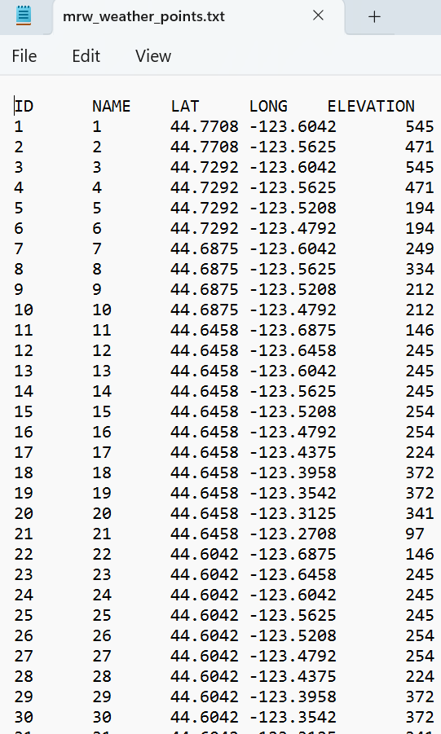
  - Note: When saving the tab-delimited text file, know that for the next script, text file needs to be organized as follows:
    - Intermediate Outputs folder
      - TextFiles folder
        - The tab-delimited text file
- Then used the script replace_tabs_with_commas:
  - Will take the tab-delimited text file and replace all tabs with commas
    - Will also save a copy of this modified text file to both the Precipitation_TextFiles folder and Temperature_TextFiles folder
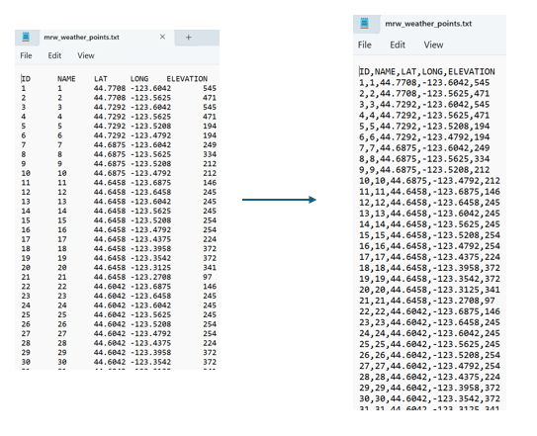
- To create a stand-alone packaged weather data folder, first created a new folder named SWAT Weather Data and then copied the folders Precipitation_TextFiles and Temperature_TextFiles into it so that final package organization was:
  - SWAT Weather Data folder
    - Precipitation_TextFiles folder (copied over)
      - 100 data text files
      - 1 locations text file
    - Temperature_TextFiles folder (copied over)
      - 100 data text files
      - 1 locations text file

